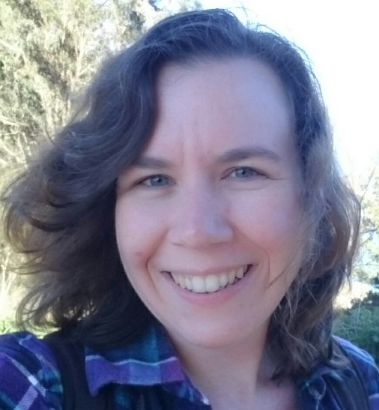
Kelly L. Edwards

IMDb: http://www.imdb.com/name/nm8284492
Reel: https://vid.me/mqQD

Film Credits:

Lee and Linda Linda Director Tengzi Zang
Con-Juncture Elaine (supporting) Director Jacklyn Eckel
Nocturnal Kandra/EP/ACD Director Terry Hall
Daymare (Ep. 2) Boss (speaking) Director John Chris Lopez
Tricky Jan (lead) Director Emmanuel Lee
The Last Sunset Wife (lead) Director Gabe Chewy
Curbside Hooker (speaking) Director Andrew Hamed
Undeniable: Joe Buck Audience (2 ep.) Executive Producer Vince Vaughn
Behind Their Eyes AP/AD Producer/Director Anwuli Okeke
Cellista Monk Producer/Director Brian Favorite
The Secret Of 40 Student Ileana Verjus of Pars Productions
Therapy commercial Wife Melissa Risso, M.A., LMFT
City by the Bay Devon's Mom Director Daniel Nowlin
Full Frontal scene Catherine (lead) Director C.J. Farmer
Grey Gardens scene Little Edie (lead) Director Seanna Lanagan
“Diaper” PSA Non-speaking Sandi Manor of Admore, Inc.
Yummy Treats Harriet (lead) Producer Dominic Stewart
The Book Ends Samantha (lead) Producer Naureen Virani
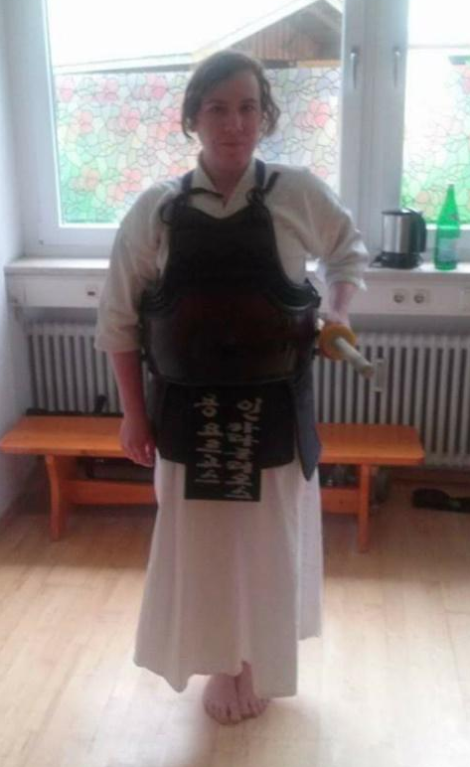
Theatre Credits:
Haunted House Lead actress/1st AD ScreamGate
Robin Hood Crone #5 Independent
Atlantis Pegasus Independent
Broadway Child extra Independent

Special Skills:
Speaks and writes Japanese & speaks German
Plays clarinet and piano
Soccer, Volleyball, Swimming, Ice Skating, Equestrian
Juggling, Yoga, Kendo (Japanese fencing)

