DAN TONKIN LINKEDIN: http://uk.linkedin.com/in/dantonkin

producer / production manager WEBSITE:http://www.danfamproductions.co.uk

Full UK Drivers License EMAIL: danfamproductions@googlemail.com
SKILLS

- Scriptwriting/Editing, Proofreading & Research – Final Draft/ Celtx/ project research/ script reporting & script editing fluency. Fluent writing for film, TV advertising, corporate and radio. Proven track record with multiple competition finalist positions.
- Producing & Editorial – Microsoft Office/ Social media management/ Project management/ Budget handling £0 - £5 million/ Pitching/ Expenses/ Carnets/ Rights clearances/ Invoices & Purchase orders/ Equipment-Location procurement and negotiation/ International professional cast and crew contacts/ call sheets/ scheduling/ release forms/ client and/or shooting team liaising.
- Directing – Actors, non-actors, interviewees/ Storyboarding/ Shot lists/ coordinating cast and crew 80+ people.
- Videography /Cameras: Video/ Digital – (Screen shots/ Focus/ Angles/ Framing) Canon 500D – 700D, 5D Mk2, Mk3, C100 - 300/ Sony Z1-Z5, GH4, HDC 1500, PMW-EX3, Panasonic 101/ Blackmagic/ Sony FS5/ Arri Mini – Alexa.
- Lighting: Gaffer – (Mood/ Tension/ Atmosphere) – Dedo/ Fresnel/ LED Lite panels/ Kino Flows.
- Sound & Location Recordist: (Definition/Sharpness) Boom Operator/ Tascam DR4 & DR7/ Sennheiser EW100.
- Equipment Handling: (Image Stabilisation) Panther/ Libec–Jib, Track & Dolly/Movi/ Shoulder Rigs/ Tripods/ C-Stands.
- File Management: Grading & Colour Image Manipulation/ Mapping & Synchronisation of Audio/ Video.
- Video Editing: – Final Cut Pro/ Adobe Premier Pro/ Vision Mixing / Video Transfer (VT) Logging/ Grading/ Graphics.

OVERVIEW & ACHIEVEMENTS: *available for UK & abroad work

- Multiple award-winning filmmaker & Royal Television Society Award Nominee.
- £0 - £5 million budget project management experience – independent to broadcast productions.
- 10 years filmmaking experience in scriptwriting, producing, directing, cinematography & editing.
- 5 years teaching experience from volunteering with Nepris to mentoring for BFI Film Academy (UK & abroad).
- Educated at Ealing Studios Met Film School & Bournemouth University to Masters level – leadership commendation.

Hollywood Talent Summit Semi-Finalist (2019)
Bucharest ShortCut Cinefest Finalist (2018)
Coverfly Red List (2018)
Signal To Noise Film Festival Judging Panelist (2017/8)
LA Film Awards Winner (2017)
Screencraft Semi-Finalist (2017)
Royal Television Society Awards Nomination (2017)
Film Expo South Three Counties Challenge Script Competition Finalist (2017)
London Screenwriters Festival Finalist (2016)
Digital Filmmaker Magazine - Interactive Film: Altered Images: ‘Survivor’ - 6 Page Feature (2016)
Nashville Film Festival Semi-Finalist (2016)
Script Reporter on Shore Scripts ‘Life Expectancy’ Winner (2015)
Screencraft Screenwriters Residency Program Finalist (2015)
PREVIOUS CLIENTS INCL.
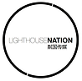
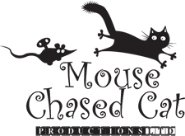
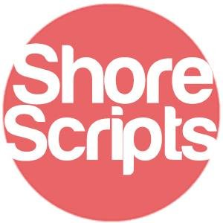
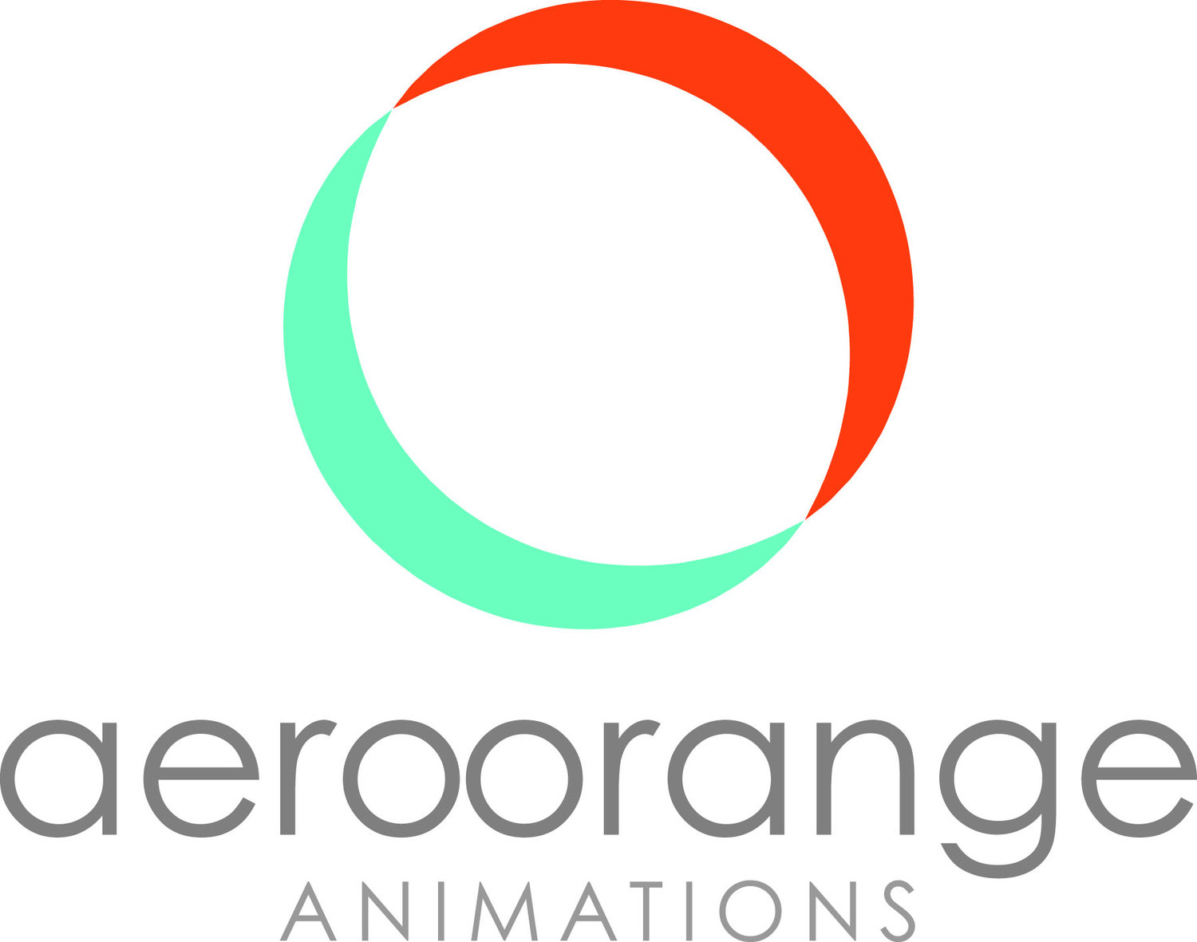

WORK EXTRACTS: *please visit website for more work

Film Showreel: https://www.youtube.com/watch?v=XA3pQFM-Qvo&t=2s
Factual & Event Showreel: https://www.youtube.com/watch?v=Z7NT7e0qjsY

Year Production Project Role | Film & TV

2019 Layla Feature Film (client: Mouse Chased Cat Productions) Assistant Producer
- proofreading and reporting of script development / story research / budget planning / cast & crew staffing / equipment bookings / scheduling / licencing of footage and music rights

2018 Imagine That TV Series Writer / Producer / Director
* Screencraft Semi-Finalist / Coverfly Red List
- all production scripting and development / seeking and securing film locations / arranging accommodation/ staffing freelance production crew, cast and equipment / location procurement / securing finance and investment / media & editorial management / assisting in sales and distribution sales materials

2018 養育前的學校 Celebrity Reality TV Series Senior Assistant Producer
(translation: Pre-Parenting School) (client: Lighthouse Nation / Tencent)
* 600 million views
- managing a team of 6 office staff & 2 location managers / storylining assistant / negotiating and securing high profile London tourist locations substitute 1st AD to production team of 80+ crew / client liaison and staffing of speciality studios and freelancers

| Animation

2018 Aero Orange Animation Series (client: Aero Orange Animations) Writer
2016 Franky & Zed Animation Feature Writer

- research and development of scripts and episode outlines, redrafting and write-ups of treatments, synopsis’ and sales materials

| Professional Shorts

2018 Toxic Deduction Short Film 1st Assistant Director
- script analysis and shot listing for camera and screen translation, time-keeping of production / scheduling and managing of cast and crew

2017 Twisted Short Film Cinematographer / Assistant Producer
- planning shot list and location recce feedback / directing of all production camera and lighting setup / managing camera and lighting team / staffing and supervision of post-production team

2017 命运 (translation: Fate) TV Series (client: Shanghai Media Group) 2nd AC
- assisting with all camera related production set ups and de-rigging / all production clapper loading and liaising with sound team

2016 Flawless Short Film Producer
* Creation Film Festival Winner / Freeview Broadcast: Cambridge
- supervising production scripting and development / seeking and securing film locations / arranging accommodations/ staffing freelance production crew, cast and equipment / location procurement / developing crowdfunding strategy and promotions

2016 Flirt Short Film Cinematographer
* Royal Television Society Nomination
- planning shot list and location recce feedback / directing of all production camera and lighting setup / managing camera and lighting team

2015 Survivor Interactive Film Writer / Producer / Director / * LA Film Awards Winner / LA Best Shorts Competition Winner / Editor
Digital Filmmaker Magazine Feature / Indie Activity Coverage
- all production scripting and development / seeking and securing film locations / arranging accommodation/ staffing freelance production crew, cast and equipment / location procurement / securing finance and investment / media & editorial management / editing all project footage & exports

| Advert & Event

2018 Cert-Tesol Interview Promo (client: Stael Ruffinelli) Videographer
- directing of all production camera and lighting setups / editing all project footage & exports

2016 Duro ‘Born To Run’ Promo (client: Osprey) Videographer
- scripting and direction of project / staffing freelance production crew and equipment / execution of all production camera and lighting / editing all project footage & exports

2016 Postgraduate Conference Speaking Event (client: Bournemouth University) Production Manager
- supervising and staffing freelance production crew and equipment for event / logging of video & audio files / client liaison and timekeeping

2016 Welsh Elections Live Event (client: BBC) 1st AC
- assisting with lens changing / setting up & de-rigging of GH9 jib studio camera team / camera operator

2016 Force For Good Promo (client: Merlin Entertainment Group) Videographer
- directing of all production camera and lighting setups / editing all project footage & exports / client liason

QUALIFICATIONS & CREDENTIALS

Saxon Court (London) CELTA Teaching Certification – Pass 2017
Grammar, Vocabulary, Reading, Listening, Speaking

Bournemouth University: MA Cinematography: Merit – 2016 x3 Royal Television Society Awards Selections
BU Short Film Competition Winner
Dissertation: Interactive Media & Archetypes BA (Hons) Scriptwriting: Grade 2:1 – 2015
Between Video Gaming & Film Leadership Commendation from Faculty Dean
Radio Drama Competition Winner

Guildford College: Access To Arts & Humanities: x4 Distinctions / x7 Merits - 2012
Philosophy, English, History, Visual Arts, Politics, Poetry, Prose, Drama, Media
Dissertation: Female Heroines; 1940’s
Scream Queens to 2000’s Action Heroes

Ealing Studios, Met Film School: Practical Filmmaking – 2008
Writing, Producing, Directing, Cinematography, Editing

