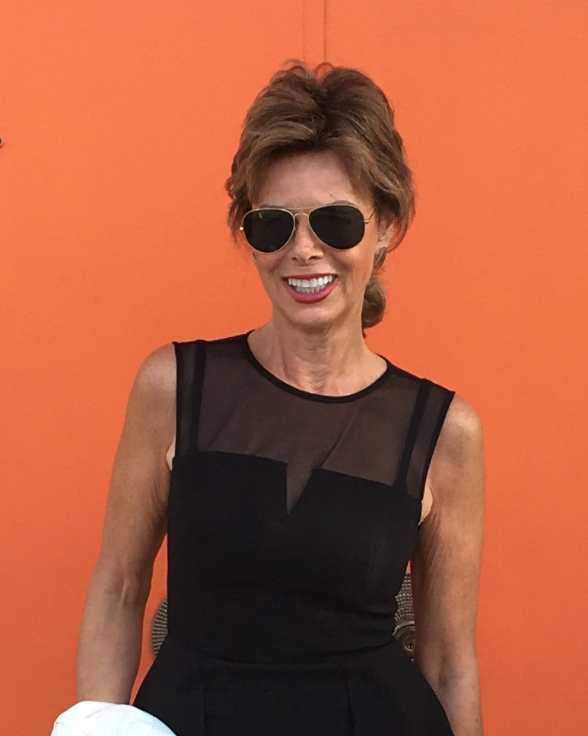

Worldwide Talent, Inc.

About Terri Lee Ryan

Terri began her career as an in-store model for Montgomery Wards. She worked as an on-air radio talent, news reporter and in sales for five years in Knoxville, TN and Chicago. As a commercial actress and model throughout her adult life, she was multi-listed with numerous Chicago talent agencies. Her clients included: Abbott Laboratories, State Farm and The Corner Bakery, where she did training films, drug roll-outs Industrial films, commercials and print work as a non-union on-air, voice and commercial print talent.

She is currently represented in Chicago in as a voice actor/over talent by Lily’s Talent Agency (www.lilystalent.com), one of the long-standing and premiere agents in the Midwest.

Terri received a B.A., Communications from the University of Tennessee and continued her training while attending classes at Act One, Ted Sarrantos and the Acting Studio, with a focus on on-camera and voice acting.

She was the co-executive producer with World of Wonder, Fenton Bailey, of the 2014 documentary, “I Married a Cross-dresser” for Sky TV in the UK. She was one of the few women producers and talent to win as a finalist in the New York Television Festival (NYTVF), where her show, “Tails in the City” was a top five winner in the unscripted comedy competition (2012) and her show “Rori’s Party” was a Life Time TV top-five finalist (2014).

As an ally of the cross-dressing and transgender communities, her blog Shades of Gender has been an important part of the gender conversation. She was a columnist for Sister House which was a popular resource for the cross-dressing community and was a contributor for the Huffington Post on gender identity issues and has contributed articles on the topic to a number of transgender organizations.

Terri Lee Ryan
terrileeryan@gmail.com
www.terrileeryan.com
(760) 408-8891

