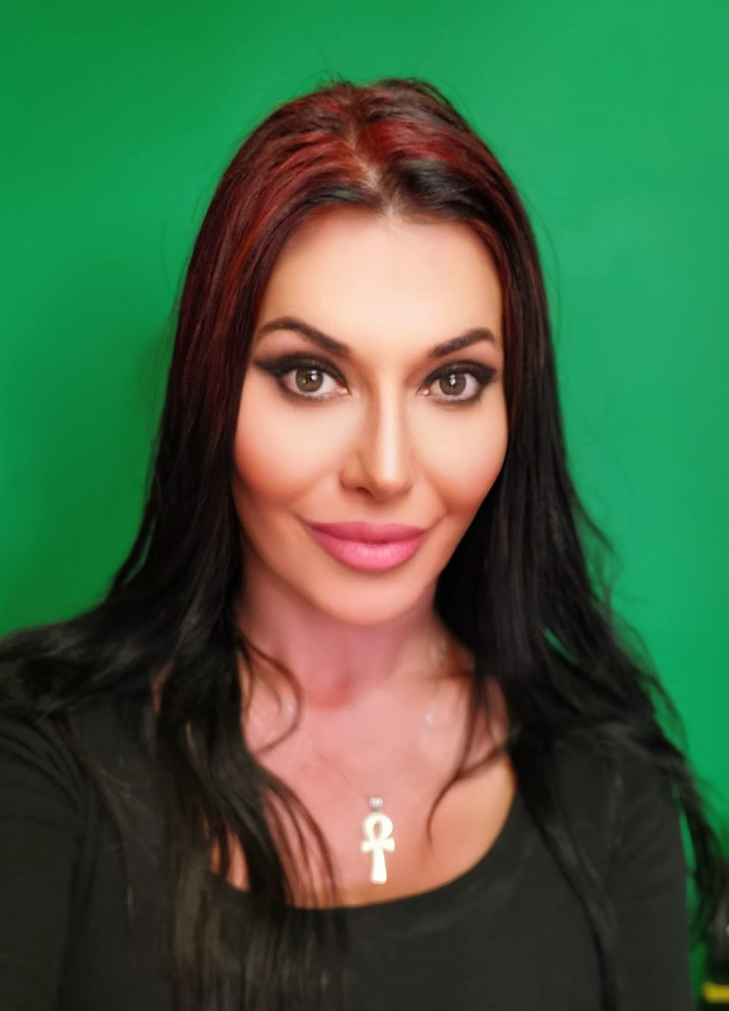 |  | Cherie Laurent  Film and Television Production
Profile  Cherie Laurent is a TV & film producer, director, actor, singer, and fashion star. After living in NYC, New Zealand, and then Sydney; Cherie is now based in Melbourne Australia, she is involved with producing new episodes of the TV show Ma-Cherie.  Appeared on Billboard magazine in New Zealand, on TV commercials (Wattie's Tomato Sauce and McDonalds), appeared in TV series (Xena Warrior princess and Hercules). Appeared as singer on Australia’s Got talent 2007.  Ma Cherie TV Show has completed over 10 seasons with over 113 episodes. Ma Cherie TV Show is on Roku, Australia TV networks, New York TV, New Zealand TV and across International Platforms. Nominated for person of the year through the British newspaper of January 2019.  Contact  PHONE:  0437 777 277  WEBSITE:  https://vimeo.com/macherietvshow  EMAIL:  Cherielaurent007@gmail.com |  | Qualifications Summary  Essan Laurent Productions – TV Producer / Director / TV Host  2006 - Present  Produced and directed TV production called Ma Cherie TV Show. Wide-ranging knowledge of film and video projects from inception to completion Effective at organizing and coordinating shoots; experience using production equipment. Conduct script analysis and contribute to script changes. Ability to write and edit scenes, treatments, and scripts; competent in film and sound editing.  Technical Proficiencies: MS Office, Studio Floor Camera HD 4K, Vegas Pro 18.0 (video and film editing software), Sound force pro 14 audio software, Acrobat reader. MAGIX PC, Coral Draw 18, Adobe Photoshop, Adobe Illustrator, Adobe Bridge, Boris FX (Creative tool for editing, Visual Effects and Motion graphics),  Strengths and Accomplishments: Enthusiastic and creative; nominated for best TV presenter, best camera work and best Art show. RMIT published a book on Cherie’s biography and various articles. In 2002, I wrote, directed, and produced 5 musical theater productions, choreographed and designed costumes for 50 dancers. Skilled Photographer, costume designer and make-up artist.  EDUCATION  RMIT university Melbourne Australia - 2020  Associated Degree in Fashion Design and technology  Graduated with distinction.  Howards Fine Acting School Melbourne Australia – 2019  Training in the dramatic arts across a range of disciplines  National Institute of Dramatic Art Sydney Australia 2002 – 2006  Training in the dramatic arts across a range of disciplines  Baghdad University 1993  Bachelor of Science – Computer technology

Selected Projects – Writer/Director/Choreographer/Producer

- Broken Wings Desirer “Feature film “(Actress)
- Running on thorns “Feature film “
- The shoe lover “26-minute film “(Actress)
- The missionary “26-minute film” (Actress)
- Male Whore “26-minute film” (Actress)
- Escape to Eden “26-minute film”. (Actress)
- Men on heat “26-minute film” “comedy”
- Constable dick and the wet cat “comedy”
- Fictitious Boundaries
- Where are u Bin “Comedy”
- We all Go “Comedy”
- Fat pizza
- Forbidden love
- Sheron Sunday school
- Innocently guilty (Actress)
- The message (Lead Actress)

Musical Theater – Writer/Director/Choreographer/Producer/Lead Actress
- 1000 Arabian Nights
- Leather and Lace
- Carmen
- Shahrazad
- Aladdin

