CHERIÉ WYATT
aka CHERIÉ
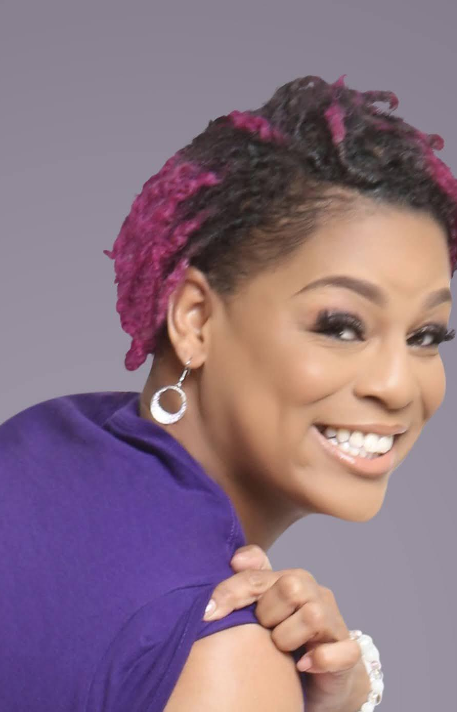
🏡2210 Beau Ln.; Richmond, VA 23223
☎️804-909-7638
📧chwyatt@live.com
🌐Stage32.com/profile/672783

EXPERIENCE
Television Commercials
Banana Boat-Louisiana Fairfield Studios
VA Lottery Park Group
Google Liquid Talent Agency RVA
Musical Theatre/Dance
Everybody's Got Issues Harvest Temple COGIC-Alice Smith
Proud 2 Be Black Just Be the Non-profit✊🏽
Videos
Drop-Plunky and The Oneness of JuJu The Marketing Group, LLC
Video for a rapper produced by Mike Bivins SportyRich Productions
Films
The Guardian A School Productions
Not Like Everyone Else NLEE(Lifetime Network Original)
Truth-the Movie B-Radd Entertainment
Web Series
Dirty South The Series Urban Anime Media
Slay Like A Mother The Mom Complex-Kate Wintsch
Socialization experiment Liquid Talent Agency RVA

TRAINING/EDUCATION
Commercial Workshop-The delCorral Agency-Commercial technique and on-camera work for a variety of products and presentation styles.
Master Class at the American Black Film Festival(ABFF)-a variety of techniques and presentation styles were reviewed and the main facilitator of the class was the Master Actor himself Bill Duke.

SPECIAL SKILLS
Proficient in Microsoft Office suite programs, Internet literate, personnel troop in the US Air Force and Army National Guard, Southern accent, motivator, and Jesus Hype Woman🧎🏽‍♀️🧘🏽‍♀️🙌🏽

