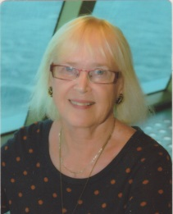
COLLEEN HENRY – BIO

NORTH WILLOUGHBY NSW 2068
AUSTRALIA

Email: chenry@atu.com.au

ACTING TRAINING AND EXPERIENCE
Colleen decided late in life to develop her creativity through acting. She attended a drop-in class at The Actors Centre Australia and had so much fun she signed up for the one-year Power of Performance course in 2004. She then went on to complete another six-month course in Acting for the Camera in 2005.
Following her training, Colleen became involved with community theatre, and was cast as Dawn in the hilarious Australian play It’s my party and I’ll die if I want to at the Chester Street Theatre at Epping. Then followed other roles in other community theatre (Pymble Players, Genesians etc). Colleen has also been involved in the Short and Sweet Festival for many years as an actor, writer and director. In 2018, her play Eliza, was included in the Sydney Fringe Festival program.

WRITING TRAINING AND EXPERIENCE
2021 Robert McKee Seminars – on-line training program – Story Drives, Character, Thriller
2021 Various short on-line seminars through Stage 32 and Masterclass.com
2020 National Institute of Dramatic Art (NIDA) - The Writer’s Studio: Writing for Performance - 6-month program – playwriting, screenwriting
2019 Arvon - Playwriting Tutored Retreat - residential in Yorkshire, UK conducted by Jessica Swale and Christopher William Hill (UK playwrights)
2014-2019 Several plays for the Sydney Short & Sweet Festival (acting/writing/directing)
2018 NIDA - Writing for the Stage (10-week program)
2018 Abridged version of Eliza presented at the Sydney Fringe Festival (writer and small role)
MEMBERSHIP – PROFESSIONAL ORGANISATIONS
- Australian Writers Guild
- Writing New South Wales
- Australian Film Institute (AFI/AACTA)

