Dana Burtin
(216) 502–0975 | South Euclid, Ohio Linkedin Profile Website
lyricalgenes@gmail.com

Height: 6’0” - Weight: 165 lbs. - Eye Color: Brown - Body type: Athletic

Credits (not limited to)
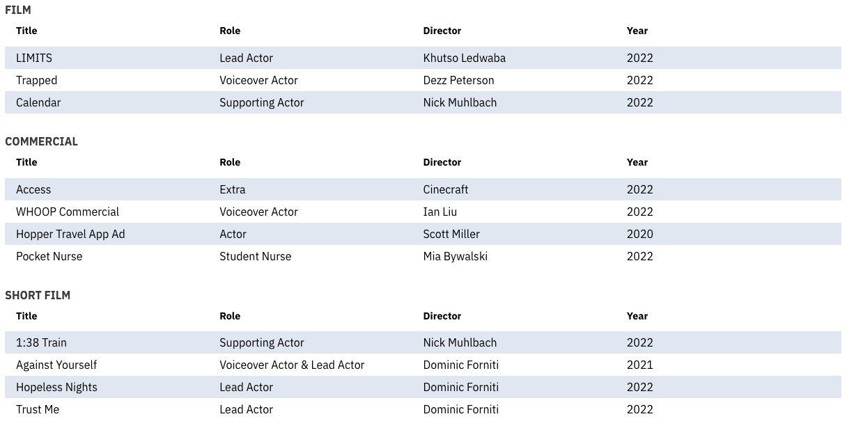
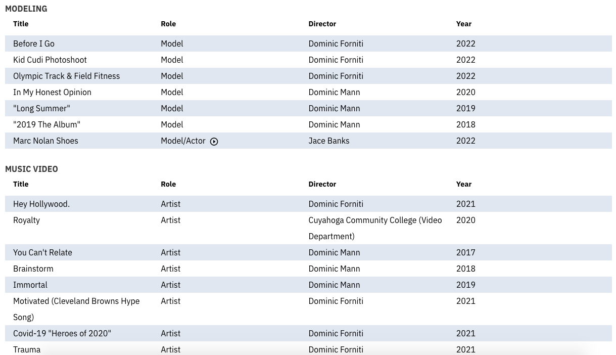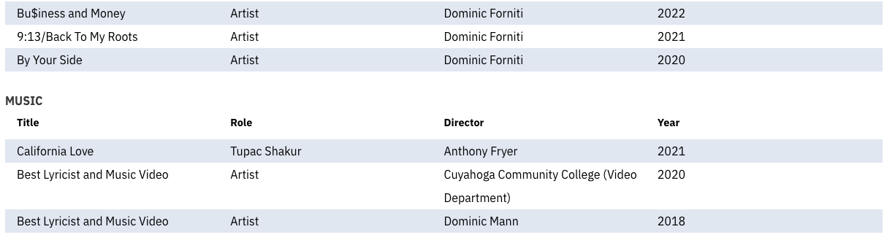

Summary
Award-winning musician performing under the moniker, “LyricalGenes”, a track athlete, working voiceover artist, actor and model, and published author/poet. Striving to transform Cleveland into a central hub for music and music business professionals through my record label, ‘Boyz II Business Entertainment’. Utilizing skills in songwriting, acting, project management, critical thinking, negotiation, marketing, and promotion to establish relationships in order to connect, learn, and reciprocate information on an entrepreneurial and personal level.

Skills
Leadership, writing, presentation, acting, lyricism, record production, songwriting, photo manipulation and editing.

Education
Cleveland State University, Liberal Arts - Cleveland, OH | 2021 - present

Cuyahoga Community College, Associate of Arts Degree - Cleveland, OH  Received full scholarship through the Honors Fellowship Society. | 2019 - 2021

References
Dee Flowers, TopHealth Services, Cleveland, OH
(216) 502-0487

David Spero, Music Business Mentor, South Euclid, OH
(216) 346–8118

Joseph Shumay, Panera Bread, Willoughby, OH
(440) 269-8320

