CURRICULUM VITAE (CV) BIO – DATA (PERSONAL INFORMATION)

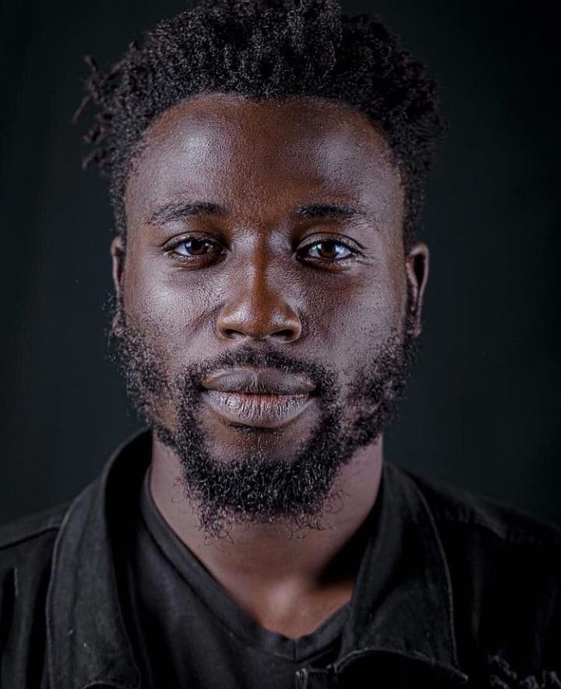

Surname : Ojambo
Other name : Enock
Contact : +256753154970
Email address: : ojamboenock18@gmail.com Date of Birth : 23rd Feb 1996
Place of Birth : Nsambya Religion : Anglican
Gender : Male
Nationality :Ugandan
Marital status :Single Home Address :Buziga Profile Summary

Ojambo Enock James is a cinematographer, Editor and script writer working in film focused on making TV drama, documentary films and corporate videos.
Ojambo Enock is a graduate from Makerere University with a Bachelors of Arts in Drama and Film Degree. During his years at University he acted in Television series like; The Campus, The game and movies like; Invasion and Hustle that gained him an IMDB credit as an actor. As a student he also engaged in numerous stage play productions as an actor, light designer, writer and also Director which manifested his passion for theatre.
After University he decided to focus on production, developing his skills in Cinematography and Editing. Under his group Aviation Studio he was able to team up with Quincy Studios and Wrist house to produce a feature film called “Circles” which was nominated in the Uganda Film Festival (UFF) in the category of best indigenous film and also in the Rwanda International Film Festival under the category of best feature film.
He later in 2019 embarked on freelance documentary film projects among the Trap music community in Kamwokya and that is where he was scouted by a member of Mapenzi Media who introduced him to the company. He joined the Mapenzi Media team with which he was able to shoot and edit shows like; Open up, Think With Maro, Cinema Drive, The Dinning Table Tales among other productions that include events, explainer videos, music videos and Adverts for Mapenzi Grill and Infinity Computers.
In his high light of 2020 he shot and edited a documentary for the release of zulitums' debut album "Invictus" and also Edited the short film called “Mbajjo” that was submitted in to the “This is Uganda Film Festival “ hosted by Ntare Mwine, the film managed to emerge as the best short film in the competition. Later the movie was adopted in to a series called “Born and Bred in Uganda” that he shot and edited with the Mapenzi Media team.
In 2021 he started up a YouTube channel called “Ojay Story” where he continues to showcase his work, providing a look in to behind the scenes of his productions and engage with his audience that is music videos, documentaries and film. He also later on joined in the editing of the yet to be released sitcom directed by Matt Bish at Bish Films.

Education Background

INSTITUTION | Year | QUALIFICATION GAINED
Makerere University Kampala-Uganda | 2014-  2017 | Bachelor of Arts in Drama and Film
St Peters College Tororo | 2013 | Uganda Advanced Certificate of Education (UACE)
St Peters College Tororo | 2011 | Uganda Certificate of Education (UCE)
Impact Primary School Mbale | 2007 | Primary Leaving Examination

Trainings
- Camera Operation, Editing and lighting for film at Wrist House Uganda.
- Script writing, Acting skills at Department of Performing Arts and Film department Makerere University.
- Public speaking skills at All Public speakers.com

- Documentary Film making at Performing Arts and Film department Makerere University

Performing Arts and Film Projects

- Support Actor in “The invasion” by Denis Dikusoka Junior.
- Support Actor in “The hustle” by Denis Dikusoka Junior.
- Support Actor in “The Game” by Dennis Dikusoka Junior.
- Camera operator for Afro-Acoustic performances for Kenneth Mugabi Songs Kibunoomu, Will you Marry Me, Akatambaala, Omusheshe. From March-April 2018.
- Producer for TV series Triangular circle Episode 1 by Isiko Abubaker, 2017.
- Actor as Guard, Servant, servant in the play King Lear by William Shakespeare in Dynamo Theatre Company. 2017.
- Camera Operator; Tebandeke’ Dream documentary film by Ssenkumba Adnan and Nanfuka Rehema. 2017.
- Actor; The campus TV series by Philip Luswata. 2016.
- Actor; The Bag, short film by Wrist House Uganda.
- Director, cinematographer and editor for Mirror an inspiration video for Aviation Studio.
- Director, cinematographer and editor; Fruit of the womb by Sammy Gideon Wetala.
- Director, cinematographer and editor; Far Away Cover by Martha perfect.
- Director, cinematographer and editor ;Deep End music Video by A1 Fresh.
- Behind the scenes camera operator; Nkwegomba Music Video shoot by Keneth Mugabi.
- 1st camera assistan; Circles with Wrist House Uganda.

Research Projects
BA Dissertation:An exploration on the impact of funding and the lack of it on the profitability of local film.

Skills attained.
- Public Speaking
- Acting Skills
- Directing Skills
- Camera operation skills
- Costume designing skills
- Scenography skills.
- Writing skills(both script and articles)

Hobbies
- Writing
- Tae Kwondo/Karatae

- Break Dancing.
- Singing

Reference

Dr. Jessica Kaahwa

(Drama Lecturer Makerere University) Email: Jessicakaahwa@gmail.com Phone: +256704567910

Mr. Philip Luswata

(Director Theatre Factory Uganda)
Email: Pluswata@gmail.com
Phone: +256750177743/+256772379979

Mr. Ssenkumba Adnan (CEO Wrist House Uganda)
Email: wristhouseuganda@gmail.com Phone: +256752876962

