Kwok Wan
Actor Dancer Martial Artist
Chinese Asian actor with an extremely short and small appearance stature of only 1.48m / 4’11 ft with a professional theatre dance, and martial arts background.
Multi lingual 5 languages fluent with affinity to do all kinds accents in each language.
Someone that takes pride in over preparing for every job given.
Flexible and always open for suggestions and eager to improve and therefore practicing and training new acting techniques and attending actors masterclasses with different acting coaches on a daily basis
"Kaizen" ; japanese for constant improvement is my religion.
Address  Amsterdam, NH, 1071 PH  Phone  +31 654 62 55 22  E-mail  hello@kwokone.com  WWW  www.kwokone.com  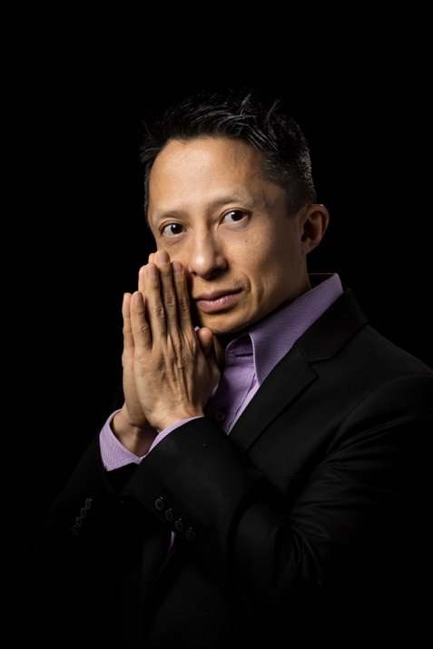
   | Contact
   | Skills
  Multi lingual Native English, German, Dutch, Chinese. Spanish and Portuguese
  Professional Theatre Dancer specialized in Dancing with very tall people , Contemporary Ballet Latin social dance Hip Hop Jazz Urban Modern Salsa Ballroom Lambada
  Professional Martial Artist 3x champion Nunchaku Do, Ving Tsun Kung Fu Master and great with butterfly knives
  Actors Type 27-45 years Very Short Asian Male 1.48M, Athletic Build, Stand Up Comedian, Criminal, Quirky, Innocent
   | Work History
  2005-07 - Current |  | Real Estate Investor  Self Employed , Delft, Zuid Holland  Currently privately owned 44 doors and 1 boutique hotel.
  2011-08 - 2022-11 |  | Films , Television, Comedy, Commercials  Television shows, Commercials, Comedy Series, London England, Amsterdam Netherlands, Warswaw Poland.  Co- star Belgium movie De Heilige Rosita director Wannes Destoop  Starring as John Lin. comedy series Canal + by director Łukasz Kośmicki  Whenever you need a tiny small actor that besides being a polyglot speaking Dutch, English, German, Chinese, Portugese or Spanish fluently, can fight and dance with tall people can book me now.
  2021-11 - 2021-12 |  | Lead Actor Dreamworld the Movie  Rouida Sherif Productions , Breda, Zuid Holland  - Learned scripts to understand characters' relationships and develop role interpretations.  - Dance in ensemble choreography  - Studied and rehearsed roles from scripts to interpret and memorize lines and cues.  - Met with production director to discuss poses, movements and persona to portray certain abstract dance elements in the movie
  2021-10 - 2021-11 |  | Co Star Actor  UHK Marije van der Hoeven, Utrecht, midden holland  Film RAUW the film  Acting and dancing in solo choreography
  2016-01 - 2018-06 |  | Professional Dancer  Korzo Theater , Den Haag, Zuid Holland  - Choreographed solo, duo and group performances for contemporary dance company.  - Coordinated with choreographers to enhance and refine movements to properly enact intended vision.
  2013-02 - 2014-06 |  | Actor and Producer  BOTH & Axell productions , Fortaleza, Ceara  Winner Best movie California Film Awards 2014
   | Education
  2022-01 - Current |  | Drama Studio University West London:  Music Arts & Drama - London
  2021-08 - Current |  | Amsterdam University of the Arts, Amsterdamse Hogeschool vd Kunsten  AHK Amsterdam Hogeschool Vd Kunsten – Amsterdam
  2020-05 - 2020-06 |  | Susan Batson Studio – Carl Ford & Susan Batson  Batson acting technique - New York
  2009-07 - 2010-06 |  | RADA Royal Academy Drama & Arts  Intensives & Short Courses – London

