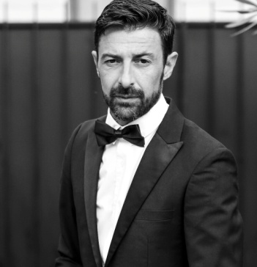
Alessandro Fiorucci

Passionate acting professional with extensive experience in variety of roles and strong background in improvisation. Dedicated to bringing best performance to projects and willing to go extra mile to deliver high-quality performances. Loves challenge of creating believable characters.

EMAIL PHONE SKILLS
alefiorucci1@gmail.com (+39)3477931054 Communication
Leadership
Teamwork
WORK HISTORY

"JAMS st. 2" 3 episode, Role: Janitor, Direct: Alessandro Celli - Series tv
STAND BY ME, ROME - 2019-07 - 2019-09

"Kidnapped" Role: Domenican Father Direct: Marco Bellocchio
KAVAK FILM , ROME - 2023-05

"The Players" Role: Colleague, Direct: Stefano Mordini
COLORADO PRODUCTION, ROME - 2019-05

"Magical Night" Role: Marshal Palmieri, Direct: Paolo Virzì
LOTUS PRODUCTION, ROME 2017-12

"From a bike ride" Role : Doctor Galbusera, Direct: Luciano Silighini Garagnani
SILIGHINI COMPANY, SARONNO (Milan) 2021-06

"Our General" Role: Captain G.I.S. Direct: Lucio Pellegrini - Series tv
RAI FICTION, ROME 2022-02

"Marshal Fenoglio" Role: Undercover Carabiniere, Direct: Alessandro Casale - Series tv
CLEMART, ROME 2022-09

"Lovely to Meet you" Role: Michael , Direct: Darwin Reina - Shortmovie
DTR TV PRODUCTION, BARCELLONA – SPAIN 2019-12

"Never Again" Role: Partisan , Direct: Alessandro Fiorucci - Shortmovie
STUDIO EMME, ROME 2020-01 - 2020-03

"A Hell of a trip to Delicias", Role : Luciano, Direct: Darwin Reina - Shortmovie
DTV TV PRODUCTION, GRANADA, NICARAGUA 2022-10 - 2022-11

"Folling for You" Role: Hommeless , Direct: Darwin Reina - Shortmovie
DTV TV PRODUCTION, LOS ANGELES, USA 2022-11

"ONE" Role: One, Direct: Alessandro Fiorucci - Shortmovie
STUDIO EMME, ROME 2017-06 - 2017-08

EDUCATION
Attore , Graduate
- SCUOLA DELLE ARTI, CIVITAVECCHIA, ITALY 2003-09 - 2006-09
Accounting, Finance, Marketing, Graduate
- LUCA PACIOLO, ISTITUTO SUPERIORE, BRACCIANO, ITALY 2006-09 - 2015-06
Act Singing, Graduate
- RECITARE CANTANDO, EFET, SAPIENZA, ROME 2006-09 - 2007-06

LANGUAGES
English - B2 - Italian - C2 - French - A2

