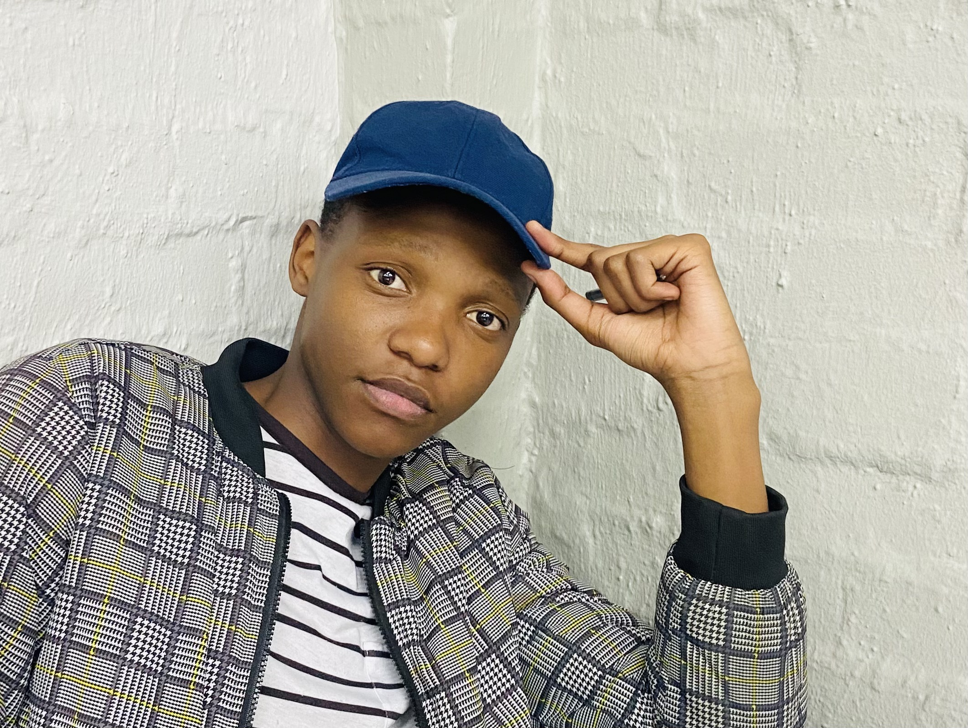 |  | SKILLS

Communication skills
Adaptability skills
Analytic skills
Critical thinking skills
Soft skills
Research skills and the ability to manage a project or study. • Good numeracy skills
• Good basic computer literacy skills (Microsoft Office
Ndivhuwo Mphephu  Profile  Well organized, creative, disciplined, and a good analytic . Experience working with a team. Has good communication skills.  CONTACT  PHONE:  0660165173  LINKEDIN:  https://www.linkedin.com/in/nicholas-mphephu-719a871ab  EMAIL  ndicksmavenda7@gmail.com  PERSONAL INFORMATION  Date of birth: 2003-11-05  Language: English, Joburg Zulu and Tshivenda  Gender: Male  National: South African  Ethnicity: Black  ADDRESS  HOME: 15169 Ext 16 Aries street Protea Glen Soweto 1818  CAMPUS: Krige St.  Park West, Bloemfontein 9301 |  | Volunteer experience

EXTRA actor

15169 Aries Street Protea Glen Soweto (my home)

October 2020
I offered my parent’s home for a short film which addresses a social issue South Africa faces, Rape. The film can be found in YouTube,”Welcome to South Africa //My Rode Reel 2020 “, a film produced by Brandon Upfold
Teachers Assistance
Club st, Sandringham, Joburg 2192,Sandringham high school

October 2021
Once assisted my mathematics teacher Mr. A Moyo in helping his grade 11 class understand mathematics topics like Finance, Probability and etc.
ACTIVITIES AND INTEREST :
Interest in music, screenwriting and acting.
Was Part of the SER 2022 UFS singing competition
Part of Starlight StageCrafters (UFS) -an acting workshop
CURRENTLY DOING
Executive Committee (Treasurer) of the VhaVenda Student Association (UFS) 2024
Peer (P3) Mentor at the University of the Free State (UFS)
House Mentor at Tswelopele Residence (UFS)
Part of the Human Rights sub committee of House Tswelopele

 |  | EDUCATION

Sandringham high school
Finished my NSC(Matric certificate)
Address :Club st, Sandringham, Johannesburg, 2192
UNIVERSITY OF THE FREE STATE.
Province of the Free State
Bloemfontein
Currently doing 3rd (Final year) Bachelor of Commerce in Accounting.
Was invited by Golden Key Honor Society for being part of the Top 15% for my 1st and 2nd year of study.

Reference
Mr. Khulekani Fakude( 2023/2024 RC First Years and Mentorship)
+27 63 100 8391
Mr. Omphemetse Sothomela (Head Mentor)
+27 67 693 1065
Mr.Mphephu( Father)
0823997571
Mr.Mahlatsi (Residence Head)
+27 73 442 0130‬‬‬‬

